Multiple-choice section

|  |  |  |  |  |  |  |  |  |  |  |  |  |  |  |  |
| --- | --- | --- | --- | --- | --- | --- | --- | --- | --- | --- | --- | --- | --- | --- | --- |
| Question | 1 | 2 | 3 | 4 | 5 | 6 | 7 | 8 | 9 | 10 | 11 | 12 | 13 | 14 | 15 |
| Answer | A | B | B | C | C | B | D | B | A | C | D | B | D | B | B |

Question 1 [5.1]

A

Sum means add, therefore x + 9 is correct.

Question 2 [5.1]

B

Liam has s – 3, so if Angela has double, she has twice that amount.

Question 3 [5.1]

B

Product means to multiply, so ab is correct.

Question 4 [5.1]

C

x, y, z

Pronumerals are letters used in an equation or expression.

Question 5 [5.1]

C

Difference means subtraction, so n – 4 is correct.

Question 6 [5.4]

B

 = 2

Question 7 [5.6]

D

The pronumeral component must be identical, so 7a is a like term.

Question 8 [5.6]

B

Collect like terms only.

4p + 5p = 9p

6 is an unlike term.

Question 9 [5.3]

A

Multiply x by 3 means 3x. Then subtract 5.

y = 3x – 5

Question 10 [5.4]

C

j = 2 × 3 + 1 = 7

Question 11 [5.4]

D

D is incorrect because 10 – 3 = 7 not 8

Question 12 [5.5]

B

Each shape uses 3 matchsticks: m = 3t

Question 13 [5.7]

D

Both x and y are positive, so (1, 5) is in the first quadrant.

Question 14 [5.8]

B

Each y value is 4 more than its x value: y = x + 4

Question 15 [5.9]

B

John is taller than Becky.

Multiple-choice total marks: 15

Short answer section

Question 16 3 marks [5.2, 5.7]

(a) The expression 2x + y + 5 contains three terms.

(b) In the expression 2x + y + 5, the ‘5’ is called the constant.

(c) The point (-7, 0) is on the x-axis.

Question 17 2 marks [5.2]

An equation has an equal sign. It is made up of two expressions that are equal to each other.  
e.g. 3x + 1 = 7y + 2

Question 18 2 marks [5.3]

A flowchart is a step-by-step instruction for performing a set task.

e.g. 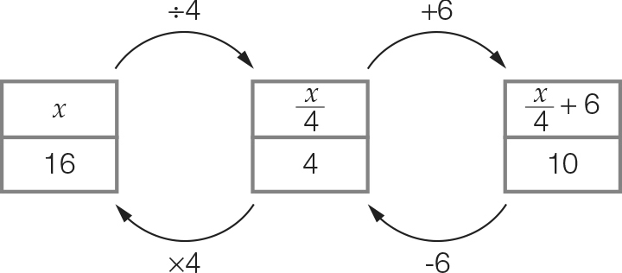

Question 19 1 mark [5.1]

Add all side lengths: x + y + z

Question 20 3 marks [5.1, 5.6]

(a) x + 5 (b) x + (x + 5) = 2x + 5

Question 21 2 marks [5.1]

1 rose = 15 petals

1 daisy = 8 petals

P = 15r + 8d

Question 22 1 mark [5.1]

There are double the number of each animal in the second diagram: m × 2 = 2m

Question 23 2 marks [5.2]

5m + 2 = 12

Question 24 6 marks [5.3]

(a) 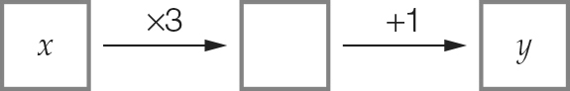

(b) y = 3x + 1

(c)

|  |  |  |  |  |
| --- | --- | --- | --- | --- |
| x | 1 | 2 | 3 | 10 |
| y | 4 | 7 | 10 | 31 |

Question 25 3 marks [5.3]

(a) y =  (b) y = 2(x + 1) (c) y = x2

Question 26 2 marks [5.3]

y = 7x – 2

Question 27 2 marks [5.3]

From each y-value subtract 6.

|  |  |  |  |  |
| --- | --- | --- | --- | --- |
| x | 4 | 6 | 10 | 14 |
| y | 10 | 12 | 16 | 20 |

Question 28 5 marks [5.3]

(a)

|  |  |  |  |
| --- | --- | --- | --- |
| Number of cards, n | 3 | 5 | 10 |
| Cost to produce the cards, C | 56 | 60 | 70 |

(b) C = 50 + 2n

Question 29 2 marks [5.4]

(a) 3(2 + 1) = 3 × 3 = 9 True

(b) 2 × 5 – 4 = 10 – 4 = 6 False

Question 30 2 marks [5.4]

|  |  |  |  |  |
| --- | --- | --- | --- | --- |
| m | 2 | 5 | 10 | 12 |
| n | 10 | 13 | 18 | 20 |

Question 31 2 marks [5.4]

w =  = 5

Question 32 4 marks [5.5]

(a)

|  |  |  |  |
| --- | --- | --- | --- |
| Number of shapes, S | 1 | 2 | 3 |
| Number of matches, M | 6 | 11 | 16 |

(b) M = 5S + 1

Question 33 6 marks [5.6]

(a) 10k (b) 6t (c) 8xy

(d) 8a – 4 (e) 7p + 1 (f) 5m + 10n + 3

Question 34 3 marks [5.6]

(a) y + x

(b) (y + x) + (y + x) + (y + x)  
= 3(y + x)  
= 3y + 3x

Question 35 6 marks [5.7]

(a) A (1, 5); B (5, 1); C (0, -2); D (-2, 1)

(b) A: 1st quadrant  
D: 2nd quadrant

(c) C

(d) (2, 2)

Question 36 7 marks [5.8]

(a)

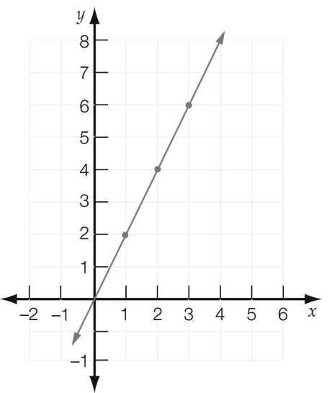

(b)

|  |  |  |  |
| --- | --- | --- | --- |
| x | 1 | 2 | 3 |
| y | 2 | 4 | 6 |

(c) y = 2x

(d) Sample answer: (4, 8)

Question 37 3 marks [5.9]

A: baby B: child C: adult

Question 38 3 marks [5.9]

(a) true

(b) false

(c) true

Question 39 8 marks [5.9]

(a) (i) A is 11 am because he rests after 1 hour.

(ii) B is 11:30 am

(iii) C is 3 pm because he has lunch for an hour.

(b) 1 km

(c) From 3 pm until 6 pm is 3 hours.

(d) 2 km + 2 km = 4 km

Short answer total: 80

Extended answer section

Question 40 6 marks [5.3]

(a) $130 + $90 × 2 = $310 (b) C = 130 + 90d

(c) 400 = $130 call out fee + $90 per hour, therefore $270 for the labour. 270 ÷ 90 = 3 hours

Question 41 10 marks [5.8]

(a)

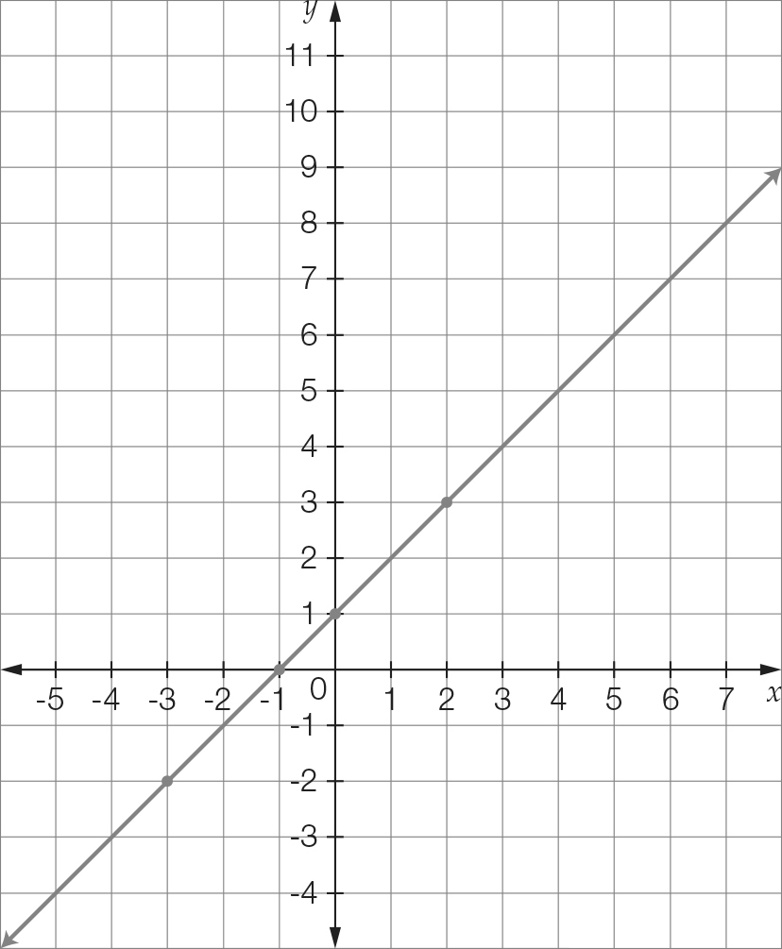

(b)

|  |  |  |  |  |
| --- | --- | --- | --- | --- |
| x | -3 | -1 | 0 | 2 |
| y | -2 | 0 | 1 | 3 |

(c) y = x + 1

(d) By tracing the line x = 5, it can be seen that the point (5, 6) is on the line y = x + 1.

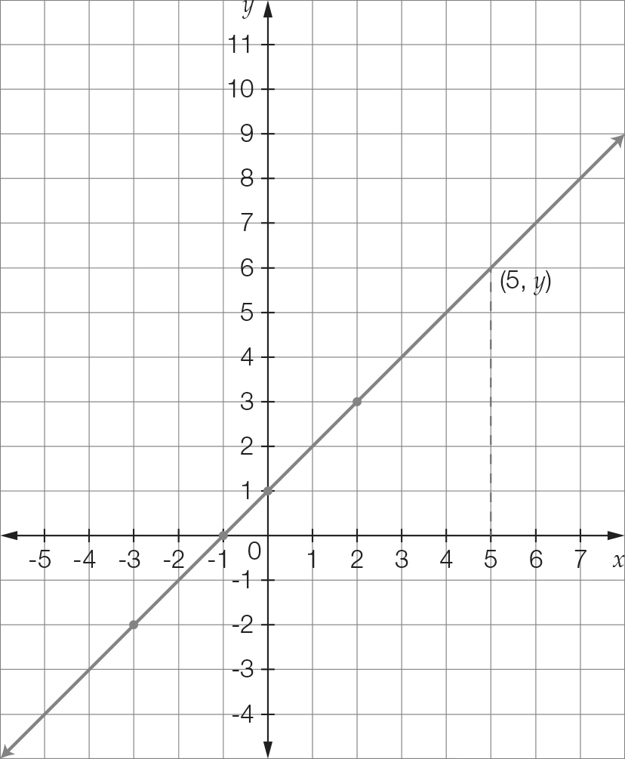

(e) No, The point (-1, 1) is above the line y = x + 1.

Question 42 4 marks [5.9]

(a) No. The cheapest car has the lowest fuel consumption but the most expensive car does not have the highest fuel consumption.

(b) The 4 cylinder car is the cheapest car to drive because it has the lowest fuel consumption.

Extended answer total: 20

TOTAL test marks: 115